Alpha Software Development Team

Community reporting App for Drug and Organized Crime Awareness

Preliminary Investigation

For the Royal Canadian Mounted Police

Prepared for: Sgt. Patrice Poitevin

Prepared by:

Hussain Farbotko-Merabaksh, Project Leader

Nicolas Castilloux

Curtis Collins

Anthony Guevara

Patrick Ings

Brian Reed

# Table of Contents

## List of Report Sections

## Project Initialization

Table of Contents 2

List of Report Sections 2

Project Initialization 2

Contact Information 3

Core 3

Project Team Leader: 3

Project Group Members 3

Project Professor And Project Advisor: 3

1. Introduction 4

2. Purpose of the Project 4

3. Users of the Project 4

4. Project Scope 5

4.1 Context Diagrams 5

4.1.1 Time Scale Diagram 5

4.1.2 Time Scale Diagram 5

4.2 Scope 6

4.2.1 Improvements 6

4.2.2 Possible additions to the scope 6

4.2.2 Restrictions 6

5. Recommendations 7

# Contact Information

Client

Sgt. Patrice Poitevin

Royal Canadian Mounted Police

Drugs and Organized Crime Awareness

Phone:(613) 296 9638

[Pat.poitevin@rcmp-grc.gc.ca](mailto:Pat.poitevin@rcmp-grc.gc.ca)

## Core

### Project Team Leader:

Hussain Farbotko Merabaksh

[hmerabaksh@gmail.com](mailto:hmerabaksh@gmail.com)

Project Leader

### Project Group Members

|  |  |
| --- | --- |
| Nicolas Castilloux  [nick.castilloux@gmail.com](mailto:nick.castilloux@gmail.com) | Curtis Collins  [wcurtiscollins@gmail.com](mailto:wcurtiscollins@gmail.com) |
| Anthony Guevara  [anthony.guev@gmail.com](mailto:anthony.guev@gmail.com) | Patrick Ings  [PatrickIngsJr@gmail.com](mailto:PatrickIngsJr@gmail.com) |
| Brian Reed  [brianreed23@gmail.com](mailto:brianreed23@gmail.com) |  |

### Project Professor And Project Advisor:

Mr. Edmund G. Strange

Algonquin College – Woodroffe Campus

Computer Studies Department

1385 Woodroffe Avenue

Ottawa, Ontario

K2G 1V8

Phone:(613)727-4723 ext 3483

strange@algonquincollege.com

# 1. Introduction

This Preliminary Investigation outlines our project group’s understanding of the Community reporting App for Drug and Organized Crime Awareness system, proposed by the Royal Canadian Mounted Police, sponsored by Sgt. Patrice Poitevin, Royal Canadian Mounted Police.The project group leader is Hussain Farbotko-Merabaksh, and the project team members are Nicolas Castilloux, Curtis Collins, Anthony Guevera,Patrick Ings and Brian Reed. The delivery date of this project is December 7th 2012.

# 2. Purpose of the Project

This project aims to improve and expand an existing application that will address the needs of our client, Pat Poitevin, of whose goal is to provide valuable and beneficial drug related information to both the RCMP and to the community.

The existing application is a website designed exclusively to gather and display information related to various drugs, where they are most commonly seen and seized, and the effects of these drugs. It is a web application that gets its information based on third party contributors. The client feels that the system has done a good job fulfilling its requirements, but is looking to improve both on its functionality as well as its interface.

This is meant to be a tool that can be used to help analyze and predict drug patterns in the community. The explicit aim is to not be a scientific tool, but a practical tool that can be of more immediate service to the community.

# 3. Users of the Project

The system will be used by a select group of individuals who come into contact with or have knowledge of drug-use in both illegal use and legal over use. The average user would be an individual who would be able to both use and enhance statistics on drug-usage for the purpose of tracking emerging trends. The input of users can range from knowledge of growing trends, new types being introduced, or symptoms of drug-usage. The usage of the system will not be available to the general public. The audience will also focus on trends in the National Capital Region.

# 4. Project Scope

## 4.1 Context Diagrams

### 4.1.1 Context Diagram

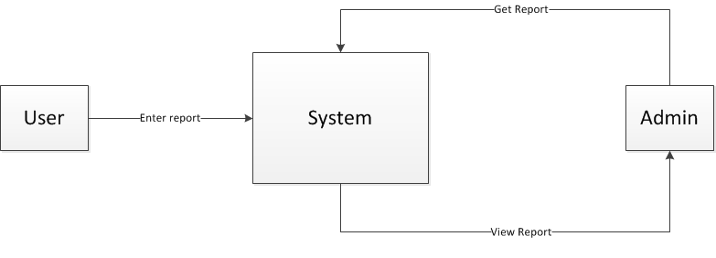

### 4.1.2 Time Sequence Diagram

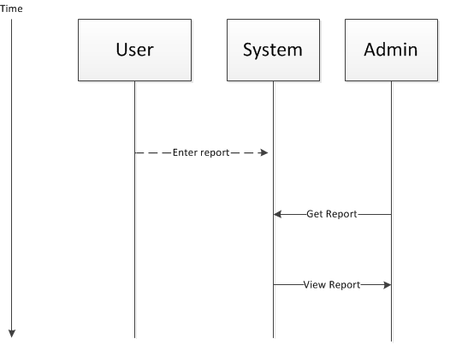

## 4.2 Scope

### 4.2.1 Required

The Alpha Software Development Team will be helping Pat improve the existing drug trend tracking website by making the following improvements:

* Improve the existing GUI for front end clients by:
  + Simplifying the visual layout and replacing graphics
  + Displaying the latest updates on the home page
* Improve the existing GUI for administrators by:
  + Grouping search options by category
  + Adding search filters for similar drug report descriptions
* Expand on existing drug description options allowing the user to:
  + Enter the size and shape of the drug
  + Enter street price of purchased drug
  + Upload pictures taken from a cell phone
* Access, import, and make use of database information provided by partnering organizations.
* Provide the user with links that the administrator has selected based on drug report.
* Test existing monthly newsletter option and add functionality for high priority messages.
* Allow people in the community to register on the website as a third party contact (i.e. Doctors, Pharmacists, Psychiatrists, Police).
* Simplifying existing pie chart creation tool interface.
* Provide detailed information for administrators when hovering over different map areas.

### 4.2.2 Desirable

If time permits we will add the following functionality:

* Allow flexibility of current drug report website to be applied in other fields (ie bully report tracking for grade school students).
* Move all text into XML files for language translation

### 4.2.2 Restrictions

This project will not:

* Be a child project with any direct relationship to the RCMP.
* Translate the current English text on the website to another language (we may provide functionality for this).
* Allow general public to access and use the site. Users must be approved by administrative staff.
* Track information regarding personal identity of the users of the site. All information submitted by a user will be anonymous and confidential.

# 5. Recommendations

We are in the process of doing further analysis to determine if all items in the scope can be achieved. After careful consideration, we as team Alpha believe that we will be able to provide Sgt. Poitevin with the requested alterations to his website, we believe that most items listed will be successfully include in our scope and delivered to Sgt. Poitevin.

In order to address the scope, our team will spend time researching popular GUI and User interface designs in the initial stages of the project, in order to determine the best user interface techniques to implement with the current website to achieve success.